The Jaguar  The Jaguar is a large feline. It is an emblematic animal. It lives in America. Its  65-80 centimetres tall, and 50-100 kilos. The meaning of its name in Guaraní  language is “the true beast”. Its jaw can break bones, it has got important claws and legs. It is a great swimmer, and it has got the ideal fur to camouflage in nature. It has got brownish-yellow fur with dark rosettes. There are jaguaretes in the wetlands in Corrientes. | 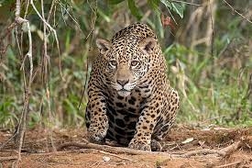
The swamp deer or Ciervo de los Pantanos  The swamp deer or Ciervo de los Pantanos is a large herbivorous animal. It  lives in the Esteros del Iberá in Corrientes. It is approximately 1.20 mts tall, it is very heavy in adult life, about 150 kg. It is brown. It has got red – brown fur in the legs. The males have got antlers. It eats grass, fruit and roots. It can run  very fast, up to 60 km/h. The swamp deer was declared a Natural Monument in the provinces of Chaco, Corrientes, Buenos Aires and Entre Ríos. | 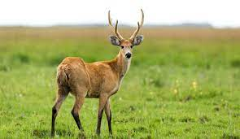
The Caiman Yacare or Yacare Overo  The Caiman Yacare or Yacare Overo (in Spanish) lives in the Esteros del  Iberá in Corrientes. There are about sixty species of reptiles in the Iberá. Two of them are the black alligator (Caiman yacare) and the alligator overo (Caiman latirostris). They are predators in the wetland. They are large animals in size, from 2 to 3 meters and they are heavy too, between 35 to 90 kg. They have got a big and heavy head with a long and thick snout and dorsal nostrils. Their tails are long and they have got a solid yaw and sharp teeth. They eat birds, fish, and mammals. They are nocturnal, strictly aquatic and aggressive animals. There are yacares in the wetlands in Corrientes. | 