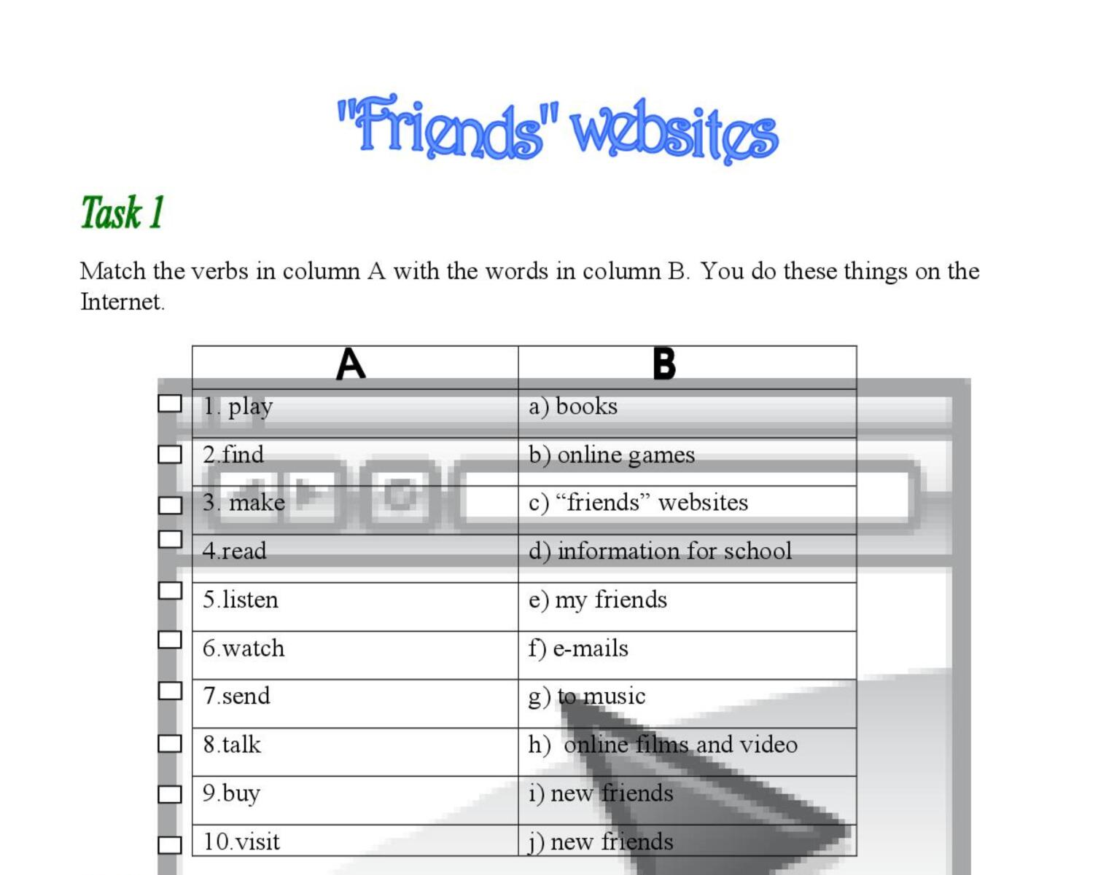
1 _b__ 2___ 3____ 4_____ 5_____
6_____ 7_____ 8____ 9____ 10______

