Inglés

Criterios de corrección

  - Comprensión de consignas: respuestas claras redactadas con coherencia y cohesión, ajustadas al contenido solicitado.
  - Respeto de las reglas ortográficas (mayúsculas, signos de puntuación, etc.).
  - Uso correcto del vocabulario específico y de las estructuras gramaticales.
  - Prolijidad y legibilidad.

Objetivos

  - Utilizar correctamente estructura del verbo BE en pasado simple y en todas sus formas. Oraciones afirmativas, negativas e interrogativas.
  - Reconocer y utilizar vocabulario y estructuras gramaticales correctamente.

Contenidos

- Pastimes
- The Past of Be
- Past of be: All forms
- Past Simple: Regular verbs (all forms)

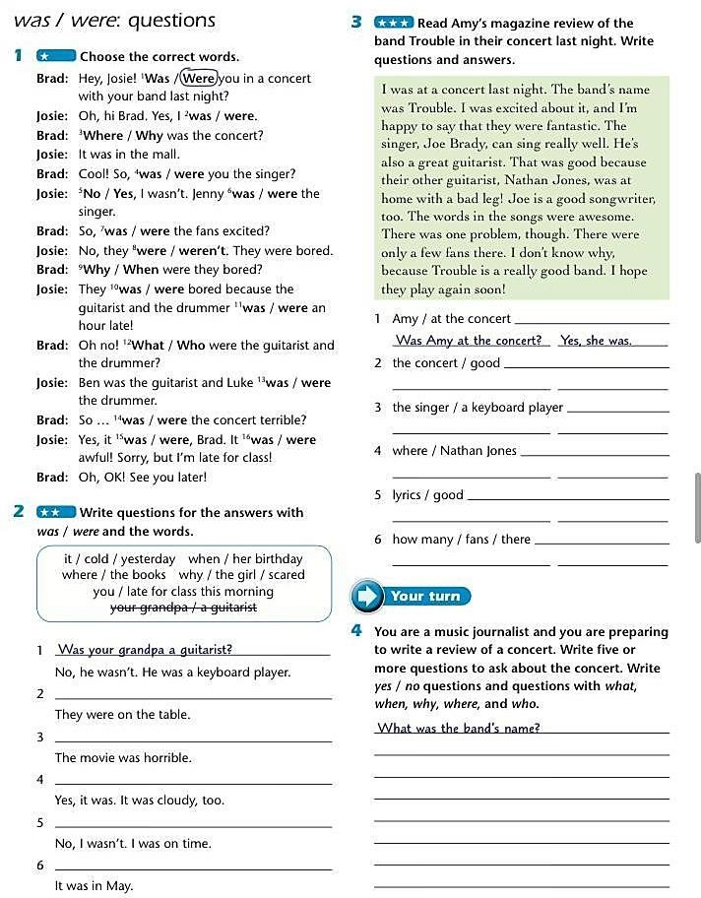
Part I
- Part II

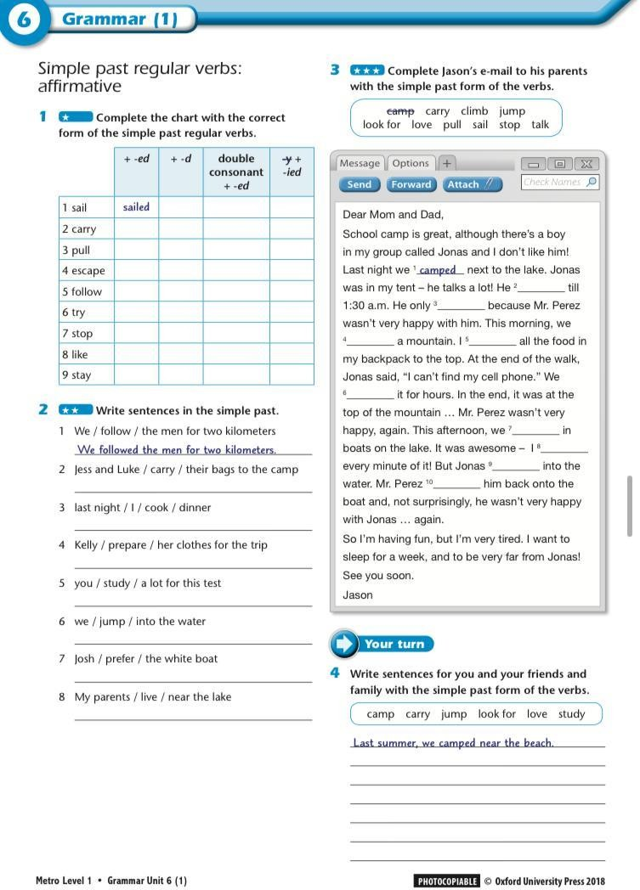

- Part III
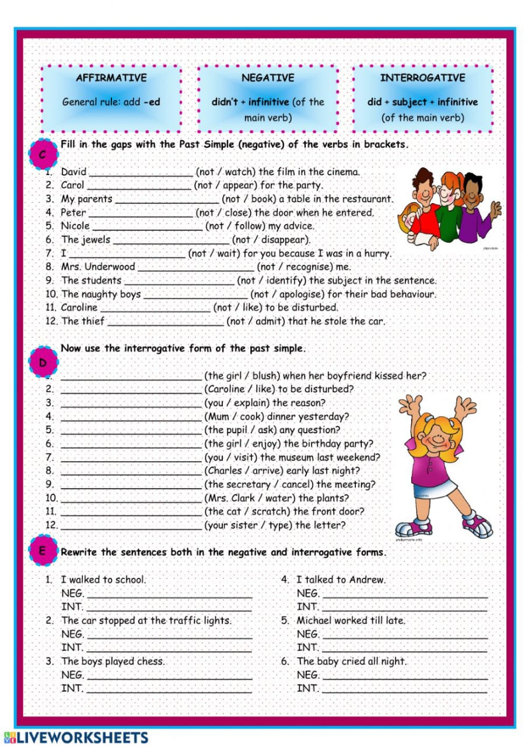
Podés usar diccionario online: https://www.wordreference.com/

- Part IV
- 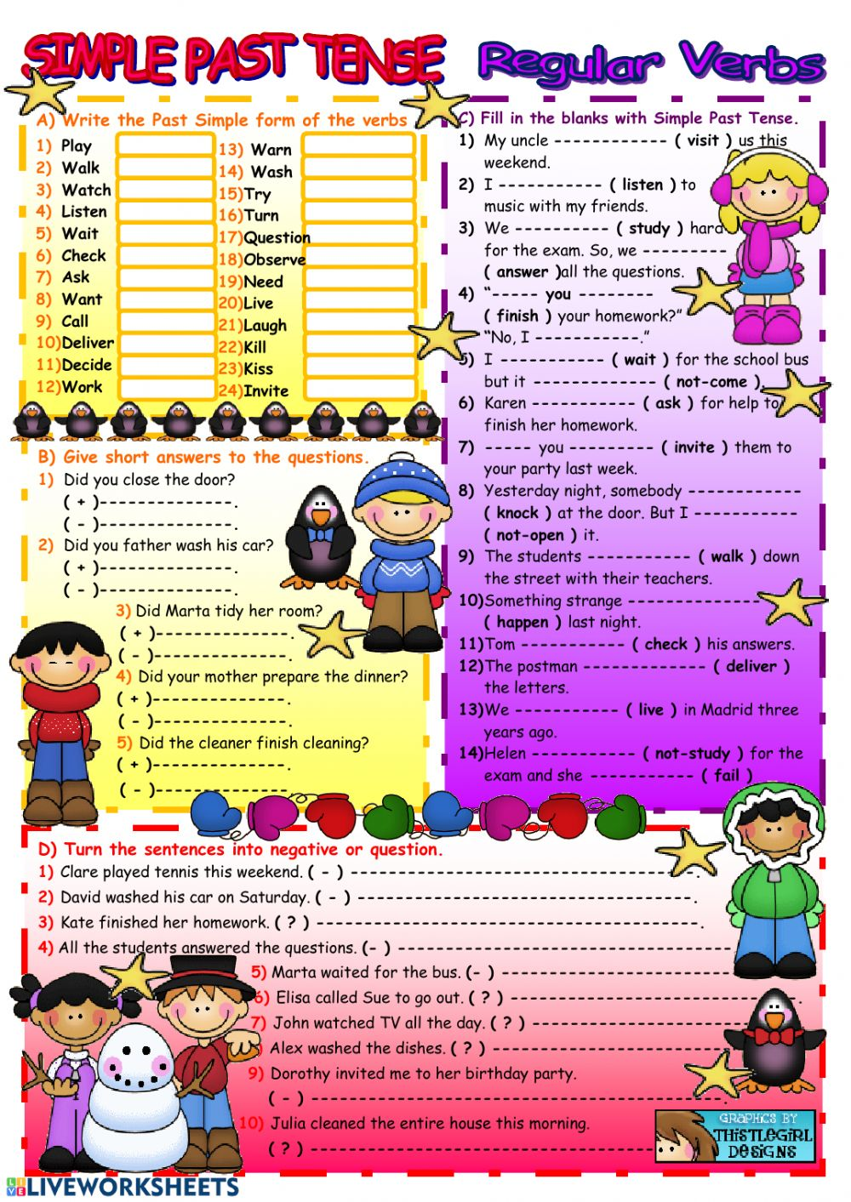

VOCABULARY

Look, G1d a1d wxite the pastime activity woxds.
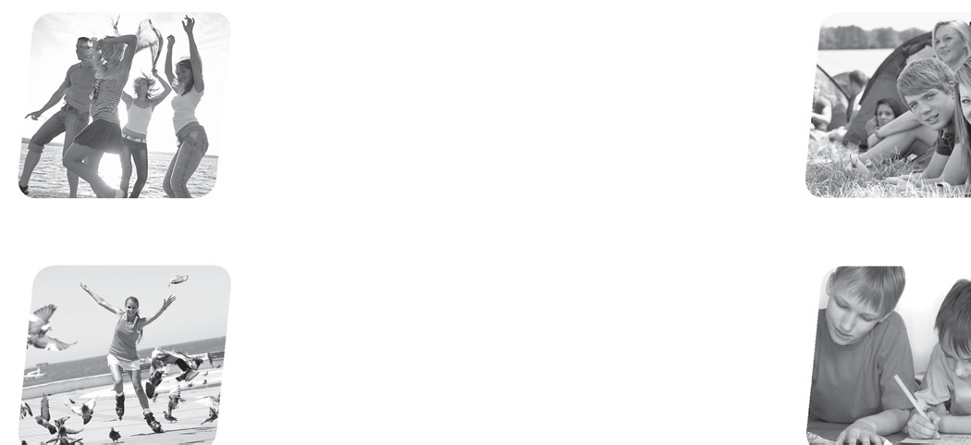





1
3
dancing
G
S R G B L V F J
D
E O P
R
X L C
A W
V Z
L E
I N G
D R
P W U
2
Q H
X R
B M
C
Z W P C U G
H
V C
L
B L
- P
- A
Y C
B D
K E U W W H
C
L S S S C T E
O Q
N S
A D
A
K I
Z M O
- J P
- C U A M P H U J
R T A
S G D
J P A
N G N
Z G C
Q E I
I C N
I N G
C I G
E I S
V
S P R K F S A K
4
    - Unscramble the words and complete the sentences.
      - We’re going camping in the country this summer. (maigpcn)
      - I’m tired because I was all night. (idnnagc)
      - Tina is a self-portrait for her art project. (wargnid)
      - My friends and I are going in the park later. (bloderlignarl)


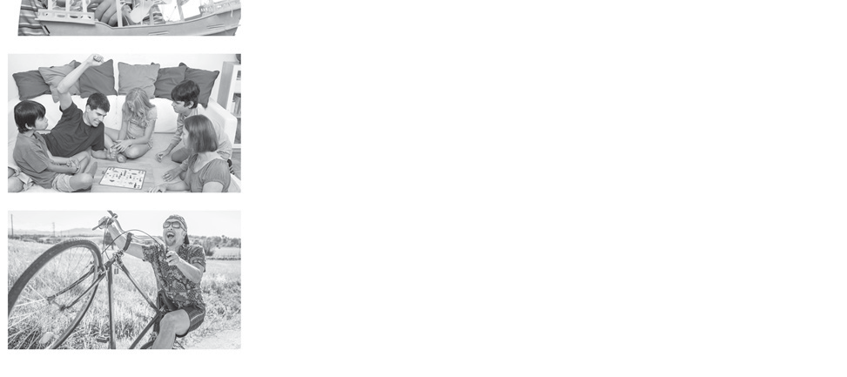



1
Look, read and match.
1
doing
board games
2
hanging out
models
3
playing
bombing
4
dive
a wheelie
5
making
with friends

2 Read and complete the sentences.
- I like hanging out with my friends on weekends.
- My friend is always on his bike.
- I enjoy in the swimming pool.
- We’re in our art and design class.
- My family enjoys
together on Sundays.

WRITING

Write about your hobbies, interests and pastimes. Write at least 5 sentences.

GRAMMAR

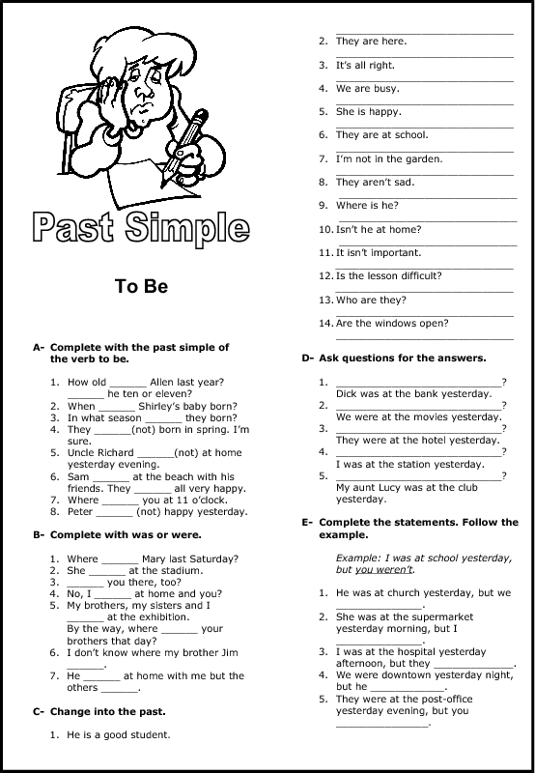

Past Simple of be
- Circle the correct options.
  - My friends was / were at the theatre last weekend.

  - Jay was / were late for P.E. this morning.
  - We wasn’t / weren’t home last week.
  - Was / Were you at the maths class on Tuesday?
  - How many people was / were at your volleyball game last night?
  - My aunt wasn’t / weren’t happy with her birthday present last year.
  - I wasn’t / weren’t in the photography club last year.
  - There wasn’t / weren’t many people at the cinema last night.

- Use was or were to complete the questions, then look and answer.

Were there many students in the classroom?

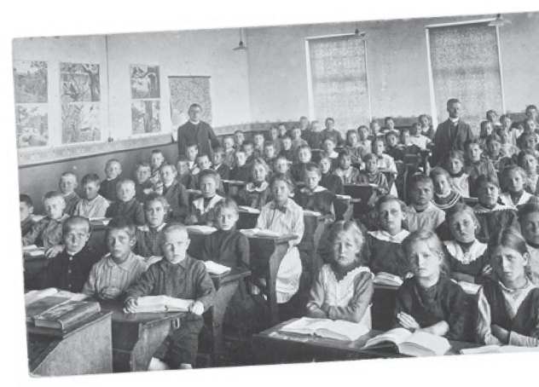
Yes, there were .

How many teachers in the classroom?
.
  - there a computer in the classroom?
.
  - there boys and girls in the same class?
.
  - there desks in the classroom?
.
  - there mobile phones in the classroom? .

- Write the sentences in the past simple. Then tick whether it was T (True) or F (False) for you.
T F
✓

  - My favourite subject is maths. My favourite subject was maths.

I am good at board games.
  - I am not good at drawing.
  - My parents are fun.
  - I am a serious student.

READING

A- Read and complete with was or were.
The best summer of my life ¹ in a little cabin with five other boys, three years ago. We ² ten years old and we ³ at that camp for three weeks. There ⁴ adults there, of course. The camp instructors organised our days into some kind of order: meals, swimming, competitions or trips to hidden places in the woods. But, there ⁵ no parents and there ⁶ no computers or video games. There ⁷ films sometimes, but the whole camp had to watch them together—even the girls. On the first day, I hated it, I wanted my bedroom, my TV and my mum’s spaghetti, but by the end, it ⁸ great! We went kayaking on the lake and hiking in the woods. I started painting—a hobby I still enjoy today. We played guitar and sang songs. By the end of the three weeks, I had so many new friends. Some of them ⁹ even girls!

B- Read again and choose the correct option.

- What is the topic of the reading?
  - memories of summer camp
  - mum’s cooking
  - outdoor sports
  - boys vs. girls
- How old was the speaker at this camp?
  - 5
  - 10
  - 11
  - 3
- How old is the speaker now?
  - 5
  - 8
  - 11
  - 13
- What was at the summer camp?
  - parents
  - computers
  - video games
  - films
- Was the speaker happy at the camp at the beginning?
  - No, because the other kids were not nice.
  - No, because there weren’t things from home.
  - Yes, because there were nice people.
  - Yes, because he liked watching films.

- How does the speaker feel about that camp?
  - He feels happy because it lasted three weeks.
  - He doesn’t think it was nice because he missed his mum’s cooking.
  - He feels happy because he discovered a creative activity he still likes.
  - He feels happy because he discovered that he is a good singer and guitar player.

- Read about Lionel Messi. Put the paragraphs in the correct order using numbers.

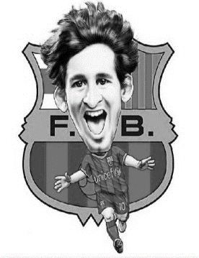
He started playing football when he was a child. When he was about eight years old, he needed a special growth treatment. The problem was that the treatment was very expensive and his family didn’t have the money to pay for it.
At present, Lionel Messi continues breaking records, scoring goals and winning league games. Diego Maradona declared that Messi was his successor and people around the globe consider Leo the best footballer in the world.
Lionel Messi was born on 24 June 1987 in Rosario, Santa Fé, Argentina. People call him Leo, Lio or La Pulga, but the name he prefers is Leo.
In 2007, Messi established the Leo Messi Foundation to help vulnerable children and in 2010 he was name Goodwill Ambassador for Unicef.
Barça realized Leo’s skill and potential and offered treatment for his growth hormone deficiency. Soon, Leo had the opportunity to play in Barcelona and he left Rosario and moved to Spain with his family.
- Write the negative form of these sentences. Then correct the sentences in affirmative form.
- Lionel started playing football when he was a teenager.
___________________________________. _________________________________.
- His family paid for his treatment.
___________________________________. _________________________________.
- He travelled to Spain alone.
___________________________________. _________________________________.
- His foundation was established in 2010.
___________________________________. _________________________________.
- Maradona declared that Messi was the best footballer in the world.
___________________________________. _________________________________.
- Unscramble these sentences.
- last / night? / Were / concert / in / a / you
_____________________________________________________________________.
- studied / for / test. / I / lot / a / this
_____________________________________________________________________.
- holidays / in / year? / enjoy / Brazil / Did / last / you / your
_____________________________________________________________________.
- cinema. / didn’t / David / at / film / the / watch / the
_____________________________________________________________________.
- yesterday / wasn’t / school / Julie / at / morning.
_____________________________________________________________________.

- Complete with the correct form of the SIMPLE PAST.
On my last holiday, I (1) __________ (visit) Aruba. I (2) __________ (travel) there by plane and I (3) __________ (stay) at a nice-looking hotel. The weather (4) __________ (be) just fabulous! It (5) __________ (not rain) any single day so I did a lot of outdoor activities. I (6) __________ (walk), around the island, (7) __________ (sunbath) at the beautiful beaches (8) __________ (play) beach volleyball and (9) __________ (learn) a lot about the culture too. But I (10) __________ (not dance) at night. My parents (11) (not be) __________ relaxed about me going to a disco o staying late out at night because we (12) __________ (be) in a foreign country, you know. But I really (13) __________ (enjoy) myself a lot! I would definitely go back to Aruba. And you should visit this place too! Where (14) __________ (be) you on your last holiday? (15) __________ you __________ (travel) somewhere?

